News Release

For Immediate Release

September 14, 2020

Forum of Federations Announces Appointments to the Board of Directors
The Forum of Federations today announced the appointments of the Honorable Christian Paradis (Canada), Ms. Beatrice Keleher Raffoul (Canada) and her Ambassador Birtukan Ayanodadi (Ethiopia) to the Board of Directors for the Forum of Federations.

Christian Paradis (Canada) is a former member of Parliament severed as Minister for Minister of International Development and La Francophonie between 2013-2015. Between 2008 and 2013 he held several federal cabinet positions, including Minister of Public Works and Government Services Minister of Natural Resources. and Minister of Industry. He also served as Quebec Lieutenant to Prime Minister Harper. In that capacity he oversaw dealings between the Quebec and the federal government. He currently serves on the board of several companies. He is a graduate of the Université de Sherbrooke and has a master's degree in corporate law from Université Laval

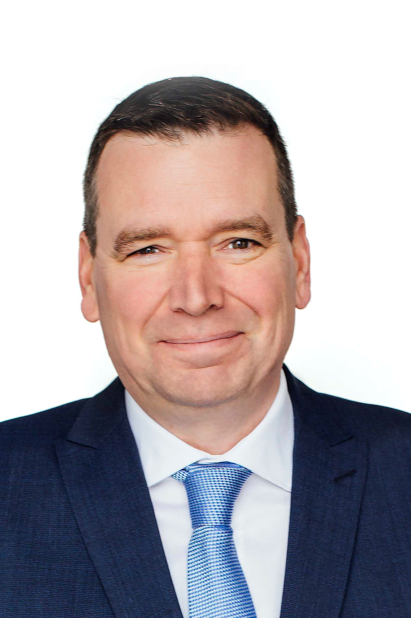

Beatrice Keleher Raffoul (Canada) is currently Chair of the Famous5 Ottawa championing for women leaders in public life. She was previously Senior Advisor to the Minister of National Defence and Veterans Affairs and the Director of Operations for the Minister of Canadian Heritage. She went on to be a Vice President for the Canadian Film and Television Production Association (CFTPA) and then Vice President, Public Affairs, for the Association of Canadian Academic Healthcare Organizations (ACAHO) which represents the research hospitals across Canada. She is a recipient of Governor General’s Volunteer Award and the Queen’s Diamond Jubilee Medal.

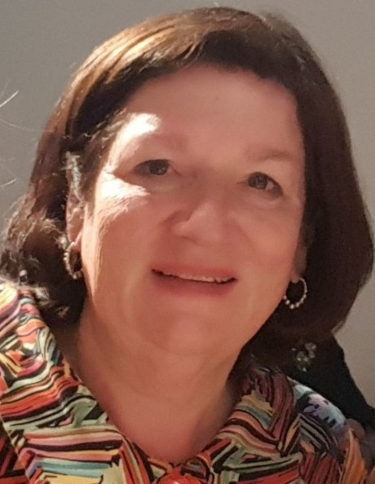

Birtukan Ayanodadi (Ethiopia) is a lawyer and career diplomat. She is currently State Minister of Foreign Affairs. She was previously Director-General for the Americas in the Ministry of Foreign Affairs of Ethiopia. She has served as Ambassador Extraordinary & Plenipotentiary of the Federal Democratic Republic of Ethiopia to Canada and Senior Counsellor International Treaties and Legal Affairs Directorate General at ministry. She currently serves on the board of directors of the Ethiopian Human Rights Council the Adama, Science &Technology University and the Ethiopian Tourist Trading Enterprise. She was educated in Ethiopia and Belgium.
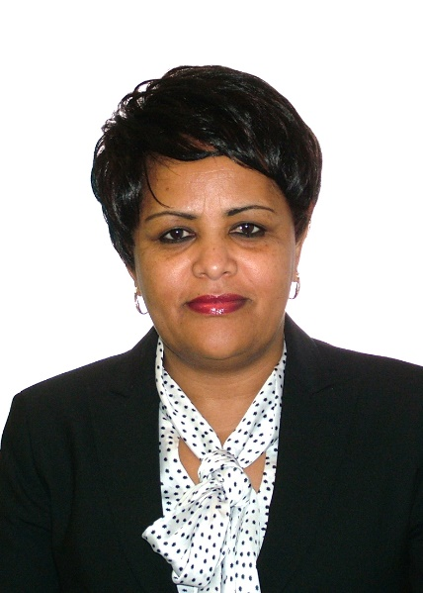

“The Forum is excited to welcome Beatrice, Birkutan and Christian as new directors,” said President and CEO, Rupak Chattopadhyay. “Their collective experience will benefit the Forum and contribute to the Forum’s mission of strengthening good governance.”

***
For further information contact: John Light, Senior Director 613-244-3360 ext 203 (light@forumfed.org).

